**Performance Report**

**Admin Platform (v1.0)**

Table of Contents

Executive Summary 3

Test Approach 3

Scope 3

Assumptions 3

Risks 3

Test Results 4

Test Results – (Continue) 7

Approval List 8

Document Reference 9

Revision History 10

# Executive Summary

The objective of this exercise is to

* Execute performance tests on the Admin portal to simulate and stress a 'production-like' workload.
* Assess Admin portal performance results matched against specific SLA requirements. (*refer to resource document* Performance Test Plan – Admin Platform)
* Report on Admin portal test results and metrics

# Test Approach

* To simulate estimated workloads through UAT metrics and expectations provided by the product owner by extracting the top web calls (using Sumo logic) over a 7 day period.
* The workload usage was achieved in the performance SIT environment with a tolerance of 1%, using 28 users (2 users to be used for recurring events)
* To execute all ‘Scope’ tests in isolation and inclusive of workload, to simulate ‘production-like’ usage of the Admin portal.
* To execute an 'Endurance' Test of the application with a significant load (including workload usage and Recurring events) over an extended period of time (duration of 33 hours), to evaluate the behaviour of the application, specific to memory consumption and utilization under sustained use.

# Scope

* Workload Usage Testing
* Endurance Testing
* Stress Testing
* Recurring Events – Admin Fee (with/without load) Testing
* Recurring Events – Insurance Premium (with/without load) Testing
* Recurring Events – Asset Management System (with/without load) Testing
* Recurring Events – Pension Payments (with/without load) Testing
* Data Feed – File Upload Contribution File Testing

# Assumptions

* ‘ like’in a dedicated Performance SIT environment.

# 

* .

# Test Results

**Workload Usage**

A workload model of the Admin portal (using Mine-UAT environment) was established by monitoring and extracting web calls over a 7 day period. Each web call was calculated as a percentage (i.e. the # of a specific web call / the total # of all web calls) to determine an accurate simulation of all use cases of the Admin portal.

|  |  |  |  |  |  |  |  |  |
| --- | --- | --- | --- | --- | --- | --- | --- | --- |
|  |  |  |  | **SLA** | | **Performance Test Results** | | |
| **#** | **Test** | **Status (vs SLA)** | **Run Date** | **Request Size** | **SLA Response Time in Minutes** | **Request Size executed** | **Response Time (Minutes)** | **Time (Hours)** |
| 1 | Workload Usage | Green | 10/05/2019 | N/A | N/A | N/A | N/A | N/A |

(Workload usage model – see above) 33 hours CPU Utilization under sustained use of 33 hours, peaked to 13% and no memory leaks were observed.

|  |  |  |  |  |  |  |  |  |
| --- | --- | --- | --- | --- | --- | --- | --- | --- |
|  |  |  |  | **SLA** | | **Performance Test Results** | | |
| **#** | **Test** | **Status (vs SLA)** | **Run Date** | **Request Size** | **SLA Response Time in Minutes** | **Request Size executed** | **Response Time (Minutes)** | **Time (Hours)** |
| 2 | Endurance Test | Green | *11/05/2019* | N/A | N/A | N/A | N/A | N/A |

**Stress Testing**

The Stress tests for the Admin portal were executed in 3 cycles of Workload usage (Workload usage model – see above), increasing the number of users (30 users maximum) and TPS (transactions per second) at each cycle, with a deliberate attempt to increase throughput beyond normal operational capacity and measure the impact and stability of the Admin Platform. (***Please refer to Fig 1-3 enclosed below***). The CPU utilization was observed in database, background and web services, showing minimal and insignificant impact throughout the whole duration.

|  |  |  |  |  |  |  |  |  |
| --- | --- | --- | --- | --- | --- | --- | --- | --- |
|  |  |  |  | **SLA** | | **Performance Test Results** | | |
| **#** | **Test** | **Status (vs SLA)** | **Run Date** | **Request Size** | **SLA Response Time in Minutes** | **Request Size executed** | **Response Time (Minutes)** | **Time (Hours)** |
| 3 | Stress Test | Green | 23/05/2019 | N/A | N/A | N/A | N/A | N/A |

Fig 1. Cycle 1 – TPS Stress Testing

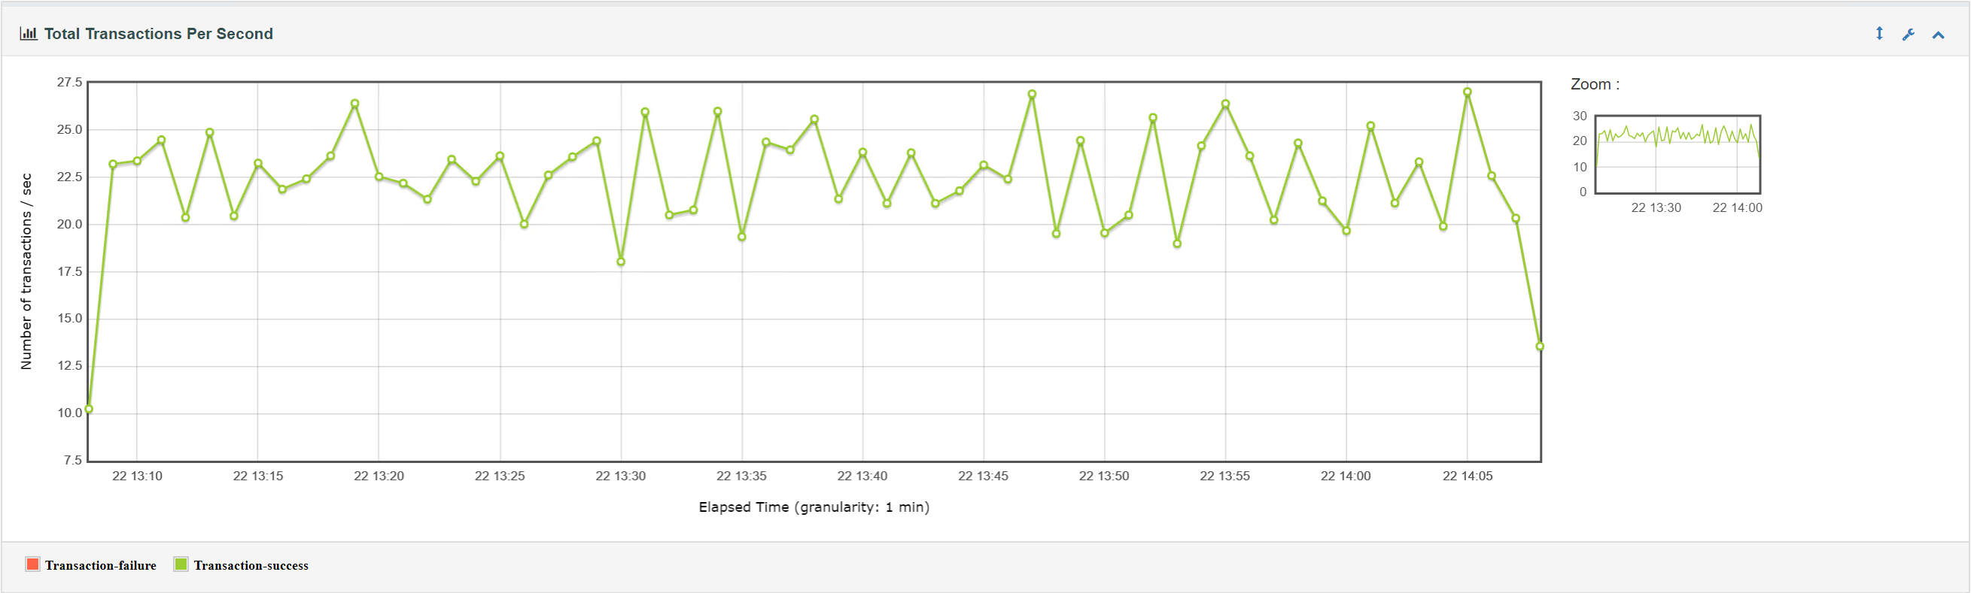

Fig 2. Cycle 2 – TPS Stress Testing

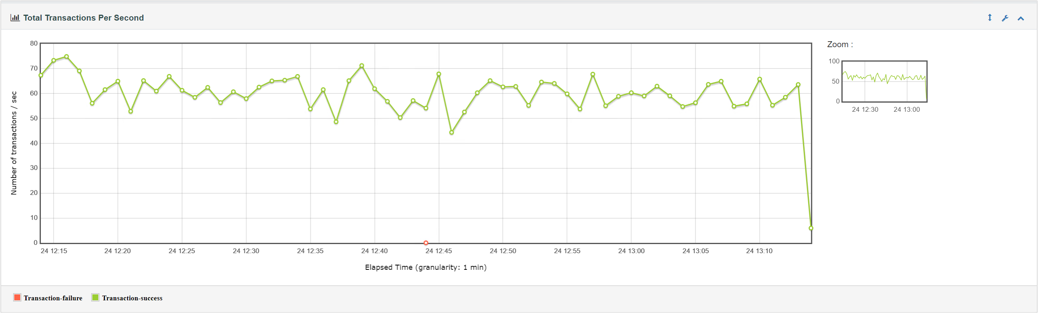

Fig 3. Cycle 3 – TPS Stress Testing

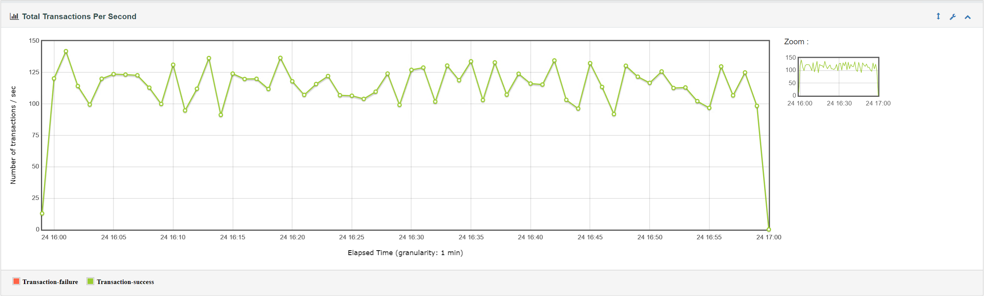

# Test Results – (Continue)

**Recurring Events (Admin Fees/Insurance Premium/AMS) and Contribution File Upload Testing**

Performance tests with a status of ‘Amber’ are currently in progress to meet revised SLA’s

|  |  |  |  |  |  |  |  |  |  |
| --- | --- | --- | --- | --- | --- | --- | --- | --- | --- |
|  |  |  |  | **SLA** | | **Revised SLA** | **Performance Test Results** | | |
| **#** | **Test** | **Status (vs SLA)** | **Run Date** | **Request Size** | **SLA Response Time in Minutes** | **SLA Response Time in Minutes** | **Request Size executed** | **Response Time (Minutes)** | **Time (Hours)** |
| 4 | Recurring Events Admin Fees under load | In-progress | 14/05/2019 | 120000 | 30 | 480 | 329000 | 780 | 13 |
| 5 | Recurring Events Admin Fees with workload | In-progress | 20/05/2019 | 200000 | 30 | 480 | 329000 | 780 | 13 |
| 6 | Recurring Events Asset Management | Green | 21/05/2019 | 120000 | 30 | 30 | 122000 | 56 | 1 |
| 7 | Recurring Events Asset Management with Load | Green | 21/05/2019 | 200000 | 30 | 30 | 122000 | 56 | 1 |
| 8 | Recurring Events Insurance Premium with workload | Green | 22/05/2019 | 200000 | 60 | 60 | 61000 | 194 | 3 |
| 9 | Recurring Events Pension Payments with Load | Green | 23/05/2019 | 6000 | 30 | 30 | 6054 | 27 | 0.5 |
| 10 | Recurring Events Pension Payments without Load | Green | 23/05/2019 | 4500 | 30 | 30 | 6054 | 27 | 0.5 |
| 11 | Recurring Events Asset Management with Load | Green | 24/05/2019 | 200000 | 30 | 30 | 188000 | 120 | 2 |
| 12 | Data Feed - File Upload - Contributions with Load | In-progress | 7/06/2019 | 8000 | 1 | 60 | 200 | 9 | 0.15 |

# Approval List

|  |  |  |
| --- | --- | --- |
| **Name** | **Title** | **Approvers/Review** |
| Corey Goodwin | Business Analyst (Mine Super) |  |
| Gavin Read | Product Owner (Mine Super) |  |
| Louis Droguett | Head of Engineering |  |
| Buddhike De Silva | Chief Technology Officer |  |
| Mark Coles | Chief Risk Officer |  |
| Steven Grant | Chief Executive Officer |  |
| Andrew Bain | Chief Operations Officer |  |

# Document Reference

|  |  |  |
| --- | --- | --- |
| **Date** | **Name** | **Owner** |
| 8th January, 2019 | Performance Test Plan – Admin Platform (v1.0) | Mine |

# Revision History

|  |  |  |  |
| --- | --- | --- | --- |
| **Version** | **Date** | **Name** | **Description of Change** |
| 1.0 | 07/06/2019 | Serge Schuetz | Initial Draft |
| 1.1 | 12/06/2019 | Louis Droguett | Review of initial Draft |